Upgrade OBIEE 11g to 12C

Reliason Solutions Limited
2nd Floor, 48-54, Moorgate, London EC2R 8EJ
+44 (0)207 7780091 | info@reliason.com | www.reliason.com

Contents
1.0 Introduction 3
2.0 Migration Process Steps 4
2.1 Pre-requisites 4
2.2 Generate BI migration to .jar file 4
2.3 Creating Export Bundle 5
2.4 Import Export Bundle 6
2.5 Perform Import using BI Migration Script 9
2.6 Validate Oracle BI Deployments 9
3.0 Post Migration Steps 10

1.0 Introduction
As you may be aware, Oracle released its latest BI tech-stack version 12c during October 2015 which is packed with abundant new enhancements and stunning new visualisations. The latest version is 12.2.1.0.0 and you can visit OTN page to learn more about it.

Here’s a quick snapshot of its features:

- It is now more Business friendly to offer agile and self-service; IT friendly to offer better governance, maintenance and easy installation
- Aligned to BI Cloud Strategy
- Introduction of .bar files and extended subject-areas for data mashups
- Alta UK skin focuses more content with cleaner page design
- Consistency across on-premise and cloud with colourful icons for better visibility
- Comes with data visualisation (separately licensed though)
- Several enhancements to graphs views, reports and dashboards
- Offers Baseline Validation Tool for comparison of data between 11g and 12c environments

To learn more about OBIEE 12c features, check Oracle’s documentation.

This blog talks about all the detailed steps involved upgrading your OBIEE 11g tech-stack to 12c version.

Basically, the upgradation is a two-step process and is carried out by using BI Migration Script (migration-tool.sh):

- create an export bundle from a read-only 11g certified Release (11.1.1.7 or later) using the BI Migration Tool (bi-migration-tool.jar)
- import the previously-generated export bundle in to the 12c system.

The BI Migration Script is used to generate the BI Migration Tool jar file.

2.0 Migration Process Steps
The entire migration process is covered by these high-level steps with more details in the later sections:

One important note to mention here is – it is going to be an Out-of-Place upgrade meaning you will be installing a new OBIEE 12c environment and then migrate metadata from OBIEE 11g environment. The new OBIEE 12c instance can be installed alongside the existing OBIEE 11g instance. Having both OBIEE 11g and OBIEE 12c instance also gives an opportunity to validate the reports in OBIEE 12c side by side with OBIEE 11g.

- Pre-requisites
- Generate BI migration tool .jar file
- Create an export bundle
- Import the exported bundle using BI 12c Configuration Assistant
- Perform import process using BI migration script
- Finally, validate Oracle BI Deployment

2.1 Pre-requisites
Take a quick look at these pre-requisites as these will help in achieving a smooth installation and avoid further re-works during the migration process:

- A working environment of OBIEE 11g (11.1.1.7 or later)
- Successfully installed OBIEE 12c environment (for download and installation steps, refer to Oracle’s documentation)
- Appropriate permissions on root files systems of both OBIEE 11g and 12c environments
- A configured weblogic authentication chain to enable 11g users to sign in to 12c domain
- 12c instance must be in STOP status

2.2 Generate BI migration to .jar file
The BI Migration Tool is self-executing and self-contained. You need to generate BI Migration Tool jar file by using BI Migration Script (migration-tool.sh). This tool will copy the RPD and Catalog along-with the necessary files so they can be used in 12c environment.

Follow these to generate BI migration tool jar file:

- Locate the BI Migration Script available at the following location.

ORACLE_HOME/user_projects/domains/bi/bitools/bin/migration-tool.sh
- Run the following command to generate the BI Migration Tool

ORACLE_HOME/user_projects/domains/bi/bitools/bin/migration-tool.sh package bi-migration-tool.jar

Replace the ORACLE_HOME with the actual path to your 12c ORACLE_HOME which is created during 12c installation.

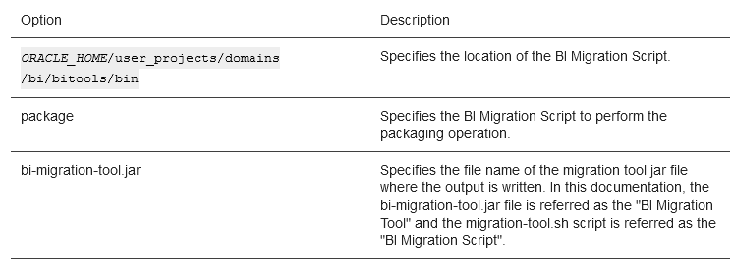
- Copy the BI Migration Tool to the host system from where you want to export data.

2.3 Creating Export Bundle
The export bundle is a ‘.jar’ file and consists of the metadata information from the 11g Oracle home.

To create an export bundle:

- Run the BI Migration Tool without passing parameters. Enter the following command:

Unix | $JDK_HOME/bin/java -jar bi-migration-tool.jar
Windows | %JDK_HOME%\bin\java -jar bi-migration-tool.jar

This command displays the list of parameters that we can include for the BI Migration Tool to locate various parts of the 11g system.

- Run the BI Migration Tool with the following parameters to create an export bundle.
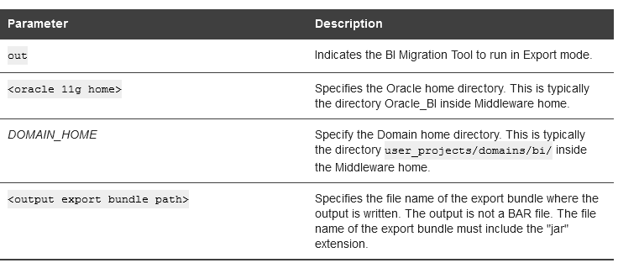
Following is a sample command for creating an export bundle:

Unix | $JDK_HOME/bin/java -jar $ORACLE_HOME/bi/migration-tool/jlib/bi-migration-tool.jar out $ORACLE_HOME/Oracle_BI1 $DOMAIN_HOME/tmp/migration-tool-test/test_export.jar
Windows | %JDK_HOME%\bin\java -jar $ORACLE_HOME\bi\migration-tool\jlib\bi-migration-tool.jar out $ORACLE_HOME\Oracle_BI1 $DOMAIN_HOME\tmp\migration-tool-test\test_export.jar

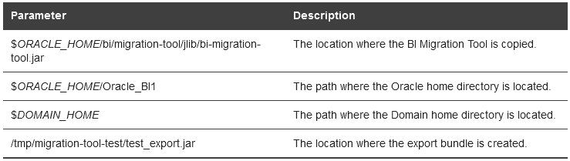
- Export succeeded message indicates a successful
- Copy the export bundle in to the 12c system

2.4 Import Export Bundle
You need to follow the below procedure only if you are configuring 12c system for the first time.

If you have already configured 12c system, you will have BI Domain and BI Service instance created. Now, need to perform the procedure to import the export bundle using the BI Migration Script.

Steps:

- Go to the bin directory using the following commands based on your operating system:

Unix | cd Oracle_home/bi/bin
Windows | cd Oracle_home\bi\bin

- Start the Configuration Assistant using the following commands based on your operating system:

Unix | ./config.sh
Windows | config.cmd

The Configuration Assistant starts and the Welcome screen is displayed.

- Select the components to install and click Next.
  - Essbase: Includes components such as Essbase Server, Cube Deployment Server, and Analytic Provider Services.
  - Business Intelligence Enterprise Edition: Includes components such as Presentation Services, Visual Analyzer, BI Composer, web services, proactive intelligence (Delivers and Actions), Web Services for SOA (WS4SOA), and Mobile Application Designer.
  - Business Intelligence Publisher: Includes Oracle BI Publisher.
The Prerequisite Checks screen is displayed.
- On the Prerequisite checks screen, after the prerequisite checks conclude with no errors, click Next.
  - If any of the prerequisite checks fail, then a short error message appears at the bottom of the screen. Fix those errors and click Rerun to try again.
  - To ignore the error or warning messages and continue with the installation, click Skip, although this approach is not recommended.
  - After this, a screen to define New Domain will appear and specify the following and click Next
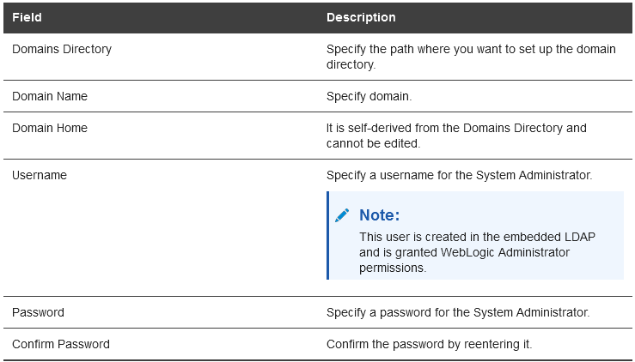
The Database Schema screen is displayed.

- On the Database Schema screen, either create a new schema or use an existing schema by clicking the appropriate option and click Next.
- On the Port Range screen, specify the port range and click Next.
- On the Initial Application screen, select the following option:

Your own existing BI Application from export bundle (.jar).

- When we select this option, we are prompted with a dialog box to select the export bundle that we created previously from the 11g environment.
- Browse and select the export bundle and click Next. The Summary screen is displayed.
- On the Summary screen, verify the values we specified on each screen. Click Save to generate a response file used for silent installation (optional). Click Configure.
- The configuration process starts and the Configuration Progress screen is displayed.
- After the configuration concludes without any errors, click Next to go to the Configuration Complete screen.
- On the Configuration Complete screen, review the configuration summary. Click Save to save the information displayed on this screen in a file. Click Finish to close the Configuration Assistant.
- The BI Application opens in the browser. We need to use the login credentials we specified while configuring to sign in to the BI application home.
- You are good to start OBIEE 12c environment.

2.5 Perform Import using BI Migration Script
Use the BI Migration Script (migration-tool.sh) to import the 11g data in to the 12c system, if we have already configured the 12c system. The BI Migration Script automatically determines the Oracle home and the Domain home directories.

To import the metadata in to the 12c system:

- Run the BI Migration Script with the following parameters:

user_projects/domains/bi/bitools/bin/migration-tool.sh in <export bundle> <service instance name>

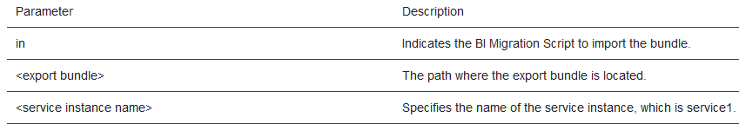
- If the migration is successful, you will see this type of message:
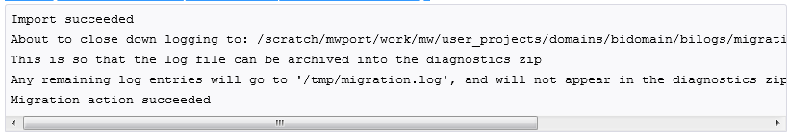
- After this step, OBIEE 12c environment can be started.

2.6 Validate Oracle BI Deployments
Now we can logon to OBIEE12c and see the Reports and Dashboards working. We can use 11g weblogic password and the Dashboards and Reports should work
- The Oracle BI Baseline Validation Tool enables to identify differences during life cycle operations, such as migrating from the Oracle BI 11g release to the 12c release.
- After we complete the migration procedure, we can use this tool to compare the two deployments and verify whether the data from the 11g environment is correctly copied to the 12c environment.

3.0 Post Migration Steps
After completing the data migration for Oracle BI EE, manually migrate the configuration settings for catalog groups and other components such as security for WebLogic and Enterprise Manager, BI Server, and BI Presentation Services.

Below are the post migration steps need to be performed after the upgrade:

- Migrating Catalog Groups
- Migrating Configuration of Oracle BI EE
- Configuring the Database to Use DataDirect Drivers
- Configuring Usage Tracking
- Configuring the SQL Server
- Adding Roles and Permissions
- Configuring MySQL for Oracle BI
- Checking the BI JavaHost Configuration
- Enabling Clusters
- Enabling Oracle Hardware Acceleration and Compatibility Mode
- Setting Compatibility Framework for Oracle BI Server
- Migrating the Fusion Middleware MapViewer Configuration
- Unchecking "Required for Authentication" Option in DYNAMIC_OLAP_LOGIN Initialization Block

For detailed instructions on post migration steps please refer to oracle’s documentation.

If you need more information, please do not hesitate to contact us at +44 (0)207 7780091 or info@reliason.com. Alternatively, visit us at www.reliason.com to learn about how we can help your Organisation on Oracle BI technologies and to access our whitepapers, case-studies and test-drives of OBIEE 11g and 12c

